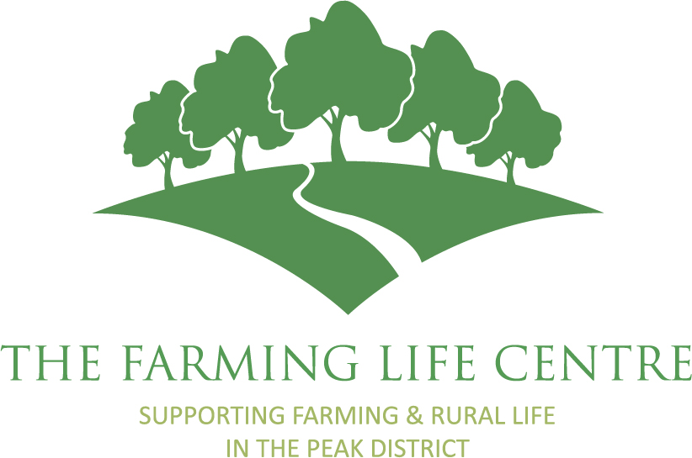
Information for CEO Applicants
Thank you for your interest in the post of CEO at The Farming Life Centre. We are an equal opportunities employer and welcome applications from all sectors of the community – those in current employment, returners to work, charitable experience in a voluntary capacity and applicants semi / retired from full time employment.
The Farming Life Centre is a small, well established charity that was founded in 2004. We provide health/well-being and business related information and support to the farming and rural community of the Derbyshire and Staffordshire Peak District. The Farming Life Centre currently performs the dual role of a project development/ delivery organisation for the local Peak District rural and farming community to address the (often hidden) health, social and economic inequalities and deprivation within the upland communities, which are delivered at outreach locations from our base at the Agricultural Business Centre in Bakewell.
The underlying ethos of all our initiatives is to improve the resilience of the farming and rural community by supporting our residents of all ages to deal with their challenges in a timely way – before they reach a point of crisis. FLC's regulated charitable objects are: "the relief of sickness, promotion of health and relief of financial hardship among the farming community in the Peak District."
The Farming Life Centre has a proven track record in providing unduplicated services. Over the years the charity has successfully developed and run projects in the fields of farm business support, mental and physical health, reducing social isolation, health and safety, network building, heritage, the arts, business development, skills development and confidence building. We have a strong legacy of working in funding partnerships – currently with the Princes Countryside Fund, Natural England, Peak District National Park, Macmillan, South Derbyshire CVS, Derbyshire Dales Council, Public Health and North Derbyshire Clinical Commissioning Group. We also have excellent connections to related rural support agencies – the Agricultural Chaplaincy, Methodist Ministry, National Farmers Union, Farming Community Network, Rural Development Agency, Young Farmers and CVS/Volunteer Bureau organisations.
The Farming Life Centre has a part time CEO, part time Office Manager, part time Rural Health Outreach Coordinator, two part time Farm Business Support Officers and a part time Rural Social Group Co-ordinator. All the operational staff work as farmers or have a farming background. We also have a small but committed group of volunteers who support us in our work. We have a diverse and experienced trustee board. See the Meet the Team Page on our website for further details on staff roles.
Our legacy - in 2001, High Peak and Dales Primary Care Trust (PCT) conducted a Health Needs Assessment of the Derbyshire agricultural community as part of the “Farm Out Health Project.” This project was set up jointly by the PCT and East Midlands Development Agency. The Assessment found that the agricultural community had a poor health profile and it revealed significant hidden deprivation. The report put forward 116 recommendations to address and respond to the issues identified, at both statutory and community level. The creation of the Farming Life Centre charity was a community response to the research.
As is the situation with most charities in the current economic environment, we are aware of the need to ensure our own sustainability to remain a driving force and anchor for our community. The stress on citizen self-sufficiency and the diminishing supply of public service resources means that The Farming Life Centre is well placed to offer timely and effective solutions via:
- The provision of services and projects which contribute to improved physical and mental wellbeing in farming and rural communities
- Support for the development / resilience of farm businesses / diversification
- The provision of information and support to members of the farming and rural community in times of challenge, hardship or crisis.
- The provision of information and support relevant to farming families and rural residents
- Signposting and general rural audience message support – including an active social media presence
- Strong partnerships and cross referral capacity with other support agencies – in particular those with a rural focus
- Ensuring our activity is data led and work towards a multi-agency approach to improve communications.
The CEO role offers the opportunity to continue raising the profile of Farming Life Centre, our aims, and to identify / increase service referrals, engagement and involvement with a variety of audiences:
- Farmers
- Rural communities
- Rural Support agencies
- Carers
- Potential carers
- GPs
- PCT/Health professionals
- Community and Voluntary partners
- Funding bodies
- Stakeholders
- Members
- Citizens in the area
- Colleagues in partner agencies
- CVS
- Voluntary organisations
- private sector/business
- other local authorities
- other statutory agencies
- Media

The annual turnover of the charity sits at circa £80k per annum. The CEO role demands a good understanding of charitable governance / administration and demonstrable experience in a variety of funding approaches towards successfully sourcing sustainable contracts / projects. To move the charity forward the CEO will need to be sensitive to the issues facing farmers and rural communities. In addition, the role requires resilience, an entrepreneurial spirit, excellent networking skills and flexibility.

