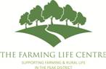

Farm Succession Planning with

Saviour Associates’ Heather Wildman

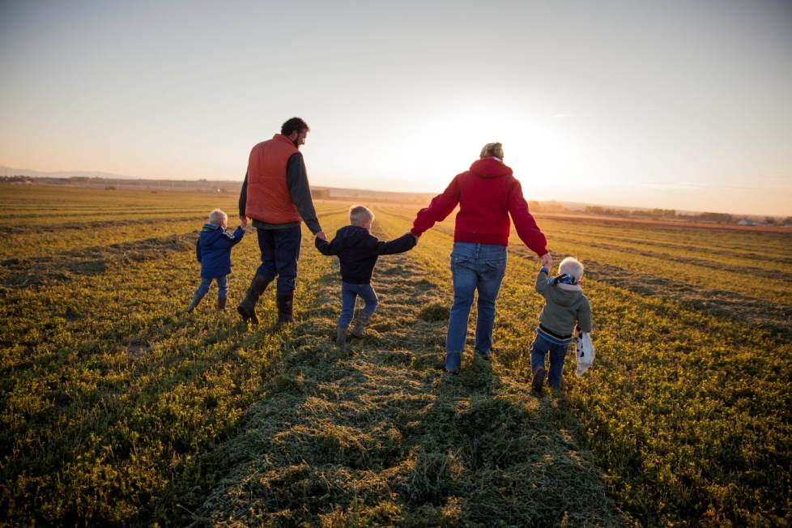

Heather will talk about the advantages of planning for the future and discuss ways to help secure the success of your business for the next generation.

Thursday 6th December 2018 11am-2:30pm

At Flash Village Hall, Flash sk170sw

[](https://www.google.co.uk/url?sa=i&rct=j&q=&esrc=s&source=images&cd=&cad=rja&uact=8&ved=2ahUKEwivrL2emdneAhVDhRoKHcUaAlgQjRx6BAgBEAU&url=http%3A%2F%2Fwww.alstonefield.org%2Fgroups-and-clubs%2Ffriendship-club%2F&psig=AOvVaw2ADdEKWgueNSqezIlowFMB&ust=1542467445709236)Free to attend. Light lunch provided.

Any questions please contact

The Farming Life Centre on :

01629810903