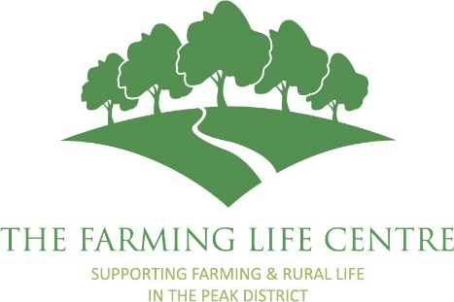
The Farming Life Centre

Equality and Diversity Monitoring Form

Rural Community Engagement Coordinator (Maternity Cover)
The Farming Life Centre is committed to promoting equality, diversity and inclusion. We ask applicants to complete this monitoring form to help us assess the effectiveness of our recruitment processes and ensure that opportunities are accessible to all.
This information will be treated confidentially and will not be made available to anyone involved in the shortlisting or selection process. The information provided will be used for monitoring purposes only.
You are not obliged to complete this form.

Age
☐ Under 18
☐ 18–24
☐ 25–34
☐ 35–44
☐ 45–54
☐ 55–64
☐ 65+
☐ Prefer not to say

Sex
☐ Female
☐ Male
☐ Prefer to self-describe: ______________________
☐ Prefer not to say

Gender Reassignment
Is your gender identity the same as the sex you were assigned at birth?
☐ Yes
☐ No
☐ Prefer not to say

Disability
The Equality Act 2010 defines a disability as a physical or mental impairment that has a substantial and long-term adverse effect on a person's ability to carry out normal day-to-day activities.
Do you consider yourself to have a disability?
☐ Yes
☐ No
☐ Prefer not to say

Ethnic Group
☐ White British
☐ White Irish
☐ White Other
☐ Mixed or Multiple Ethnic Groups
☐ Asian or Asian British
☐ Black, Black British, Caribbean or African
☐ Arab
☐ Other Ethnic Group - If you wish, please specify: ______________________
☐ Prefer not to say

Religion or Belief
☐ No religion
☐ Christian
☐ Buddhist
☐ Hindu
☐ Jewish
☐ Muslim
☐ Sikh
☐ Other religion or belief – If you wish, please specify: ______________________
☐ Prefer not to say

Sexual Orientation
☐ Heterosexual / Straight
☐ Gay Man
☐ Gay Woman / Lesbian
☐ Bisexual
☐ Other – If you wish, please specify: ______________________
☐ Prefer not to say

Caring Responsibilities - Do you have regular caring responsibilities for any of the following?
☐ Child or children
☐ Adult dependent relative
☐ Person with a disability or long-term health condition
☐ Other caring responsibilities - If you wish, please specify: ______________________
☐ None
☐ Prefer not to say

How did you hear about this vacancy?
☐ The Farming Life Centre website
☐ Social media
☐ Friend or colleague
☐ Community organisation
☐ Job website
☐ Other - please specify: ______________________

Thank you for completing this monitoring form.

