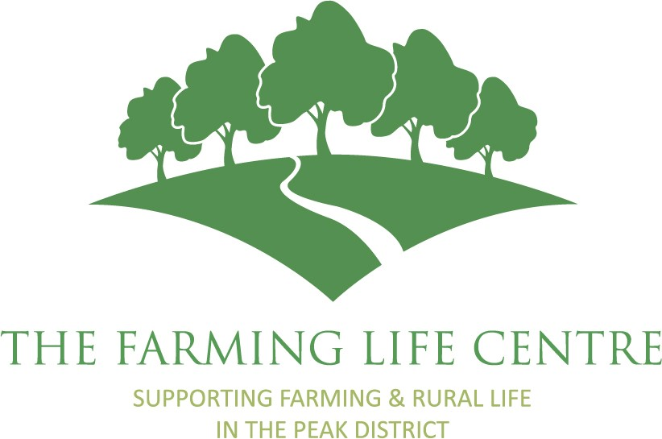
The Farming Life Centre
Application for the Post Of
Rural Community Engagement Coordinator
Please note, your personal details will be removed from your application prior to the short-listing process.
PERSONAL DETAILS
Full Name:
Address:

Postcode:
Telephone No (Daytime): |  | Mobile No:
Email:
REFERENCES: Please give the details of two relevant referees. If you are employed this should include your present employer.
May we contact your referees before interview?
☐ Yes ☐ No
Referee 1  Name:  Job Title:  Address:  Email:  Tel No: |  | Referee 2  Name:  Job Title:  Address:  Email:  Tel No:
Application process: We are committed to ensuring our recruitment process is accessible to all applicants. If you have a disability or require any reasonable adjustments to support you with your application or during the recruitment process, please let us know and we will do our best to accommodate your needs.
Do you require any reasonable adjustments to support you during the application or recruitment process?
☐ No ☐ Yes
If yes, please provide details:

DECLARATION OF INTENT: I confirm that I am submitting this as an application for the post of

Rural Community Engagement Coordinator

The information contained within this application is correct to the best of my knowledge.
Signature: Date:
Education History: Please give details of all education and any qualifications achieved.

Date: | Subject/Course | School/College etc | Qualification

Training: Please include career development, personal development and any training relevant to the post.
Date: | Subject/Course | Training Provider | Qualification

Employment/Self-employment History: Please give details of all employment, including self-employment. (Most recent listed first)
Job Title:
Name/Address of Employer (if applicable):
Dates employed:
Main responsibilities:

Job Title:
Name/Address of Employer (if applicable):
Dates employed:
Main responsibilities:

Job Title:
Name/Address of Employer (if applicable):
Dates employed:
Main responsibilities:

Job Title:
Name/Address of Employer (if applicable):
Dates employed:
Main responsibilities:

Job Title:
Name/Address of Employer (if applicable):
Dates employed:
Main responsibilities:

Job Title:
Name/Address of Employer (if applicable):
Dates employed:
Main responsibilities:

Skills, Knowledge and Experience: Please use this section to describe and demonstrate how you meet the requirements of the job description and person specification, providing examples where possible.

Please continue on a separate sheet if necessary.
Other Information: Please explain why you are interested in this role and provide any additional information that supports your application.

When completed please return this form to:
The Farming Life Centre,
Agricultural Business Centre,
Agricultural Way,
Bakewell,
Derbyshire,
DE45 1AH
Or email: rachel@thefarminglifecentre.org.uk to arrive no later than 5pm on Monday 29th June 2026

